NEVADA OPERATIONS CENTER (NVOC) SITREP
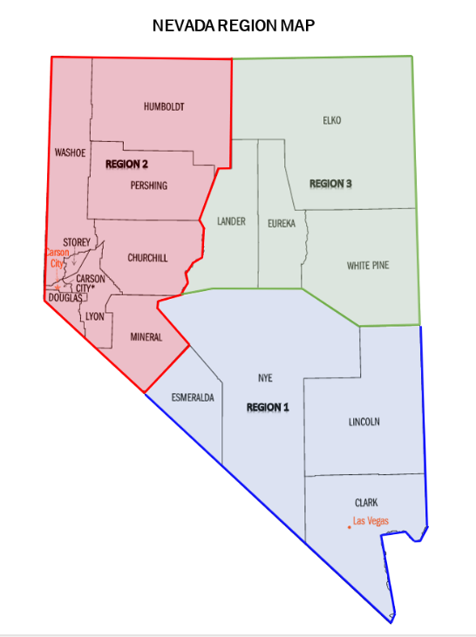
INCIDENT NAME: Spring Thaw 2023
LOCATION: Nevada (Region 2 and 3)
TIME OF INCIDENT: 12:00 AM on 8MAR23
INCIDENT DESCRIPTION: The Nevada Operations Center (NVOC) is partially activated per the Division of Emergency Management (DEM) Spring Thaw Plan. The purpose of this activation is to increase our efforts for monitoring and preparedness.

SITREP #: 3
SOURCE: Nevada Division of Emergency Management (DEM), Nevada Department of Transportation (NDOT), Walker River Irrigation District, and National Weather Service (NWS) Elko, Las Vegas, and Reno.

CONDITIONS
CURRENT SITUATION (as of 1600 PM on 01JUN23): Per the NWS Reno, thunderstorms expected again this afternoon but less numerous, flooding concerns persist. Seasonal temperatures will keep snowmelt stagnant through the end of the week, though minor warming over the weekend may briefly increase snowmelt. Unsettled, stormy weather is favored for next week beginning on Sunday. The East Fork/Mainstem Walker River will continue to see moderate flooding and the Carson River system will continue to see minor impacts in agriculture and open spaces. The Humboldt River will see rises this week as flows work their way towards Winnemucca and Imlay. The Walker River near Wabuska is at moderate flood stage of 12.2 feet. The Walker River near Mason – Snyder Lane is at moderate flood stage at 11.29 feet. The East Fork Carson River near Gardnerville is at near flood level of 12.77 feet. A Flood Advisory is in effect through 02JUN23 in Lyon County for a dam floodgate release. Per the NWS Elko, afternoon and evening shower and thunderstorm activity across much of the region. The Humboldt River a Comus is at moderate flood stage of 10.9 feet. The Humboldt River at Battle Mountain is at moderate flood stage of 10.68 feet. Humboldt River at Palisade is at near flood stage of 6.62 feet. Flood Warning continues for Humboldt River affecting Elko, Lander and Humboldt counties and moderate flooding is forecast for the Lower Humboldt areas of Palisade, Battle Mountain and Comus.

Spring Thaw 2023 Declarations
Churchill County 3/6 | Fallon Paiute-Shoshone Tribe 4/7
Lincoln County 4/12 | Lander County 4/27
Humboldt County 5/1 | Lyon County 5/18
State Declaration 5/29 | Walker River Paiute Tribe 5/30



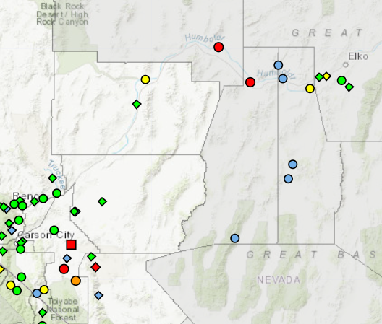

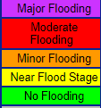

ACTIONS and NEEDS
Jurisdictions
Region | Location
Region 2 – Western Nevada | Lyon County –  - Miller Lane closed, between 95A and Aiazzi Ln  - Protective measures taken to protect entry points of water system  - Mason Bridge closure delayed due to successful mitigation efforts  - Up to 10 homes impacted by flooding  - DEM and FEMA officials made site visit  - Resource request for Spanish-English interpreter  - Flooding at Mason Valley causing difficulty with transportation at fish hatchery  Walker River Paiute Tribe –  - Evacuation planning underway for worst case scenarios  - Working with BIA on the dam at Weber Reservoir  - Resource request for 12, 800 MHz radios en route  - Resource request for 2500’ Visqueen Plastic Material en route  - Resource request for 3,500 sandbags and sandbag machine en route
Region 3 – Eastern Nevada | Elko County –  - Monitoring Lamoille Creek at record flow

State Response
ESF 1 Transportation | - NDOT ensuring their app reflects road closures in Lyon County
ESF 4 Firefighting | - NSTR
ESF 6 Mass Care | - Shelters available
ESF 8 Public Health | - NSTR
ESF 10 Hazardous Materials | - Working on removing oil barrel at Walker River Paiute
ESF 11 Agriculture | - NSTR
ESF 12 Energy | - NSTR
ESF 13 Public Safety and Security | - NSTR
ESF 15 External Affairs | - NSTR
ESF 16 Military Support | - NSTR
Tribal Liaison | - Assisting Tribal Nations with requests
AFN Liaison | - NSTR
FEMA Liaison | - NSTR
USACE Liaison | - NSTR
PDA Team | - NSTR

AVAILABLE RESOURCES (see photos on page )
Division of Emergency Management
Resource | Number
Sandbags | 8,500
HESCO Barriers | 20 pallets in Carson City, 26 in Eureka
Sandbag Fillers | 1
Express Sandbaggers | 5
ITS Logistics Truck | 1

COSTS
Division of Emergency Management
Total | $101,150

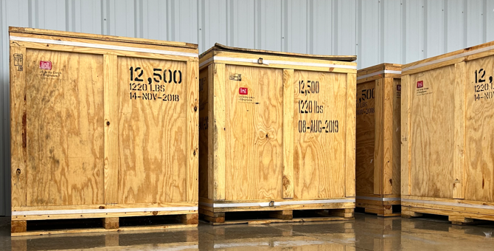
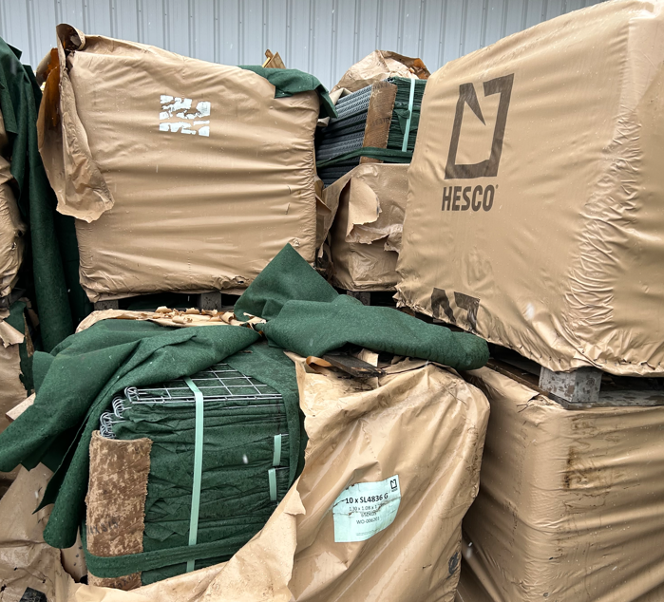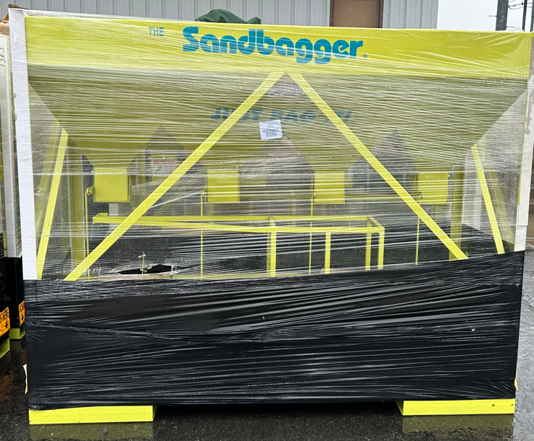
COMMENTS AND FOLLOW-UPS
LINKS: https://dem.nv.gov/Resources/Flood_Information
NEXT R2 COORDINATION CALL: 06JUN23 at 9:00 AM
DEM DUTY OFFICER: Eric Wilson (775) 687-0498

